When it comes to money, having a plan will help you live better.
Ready to take your financial wellness to the next level?

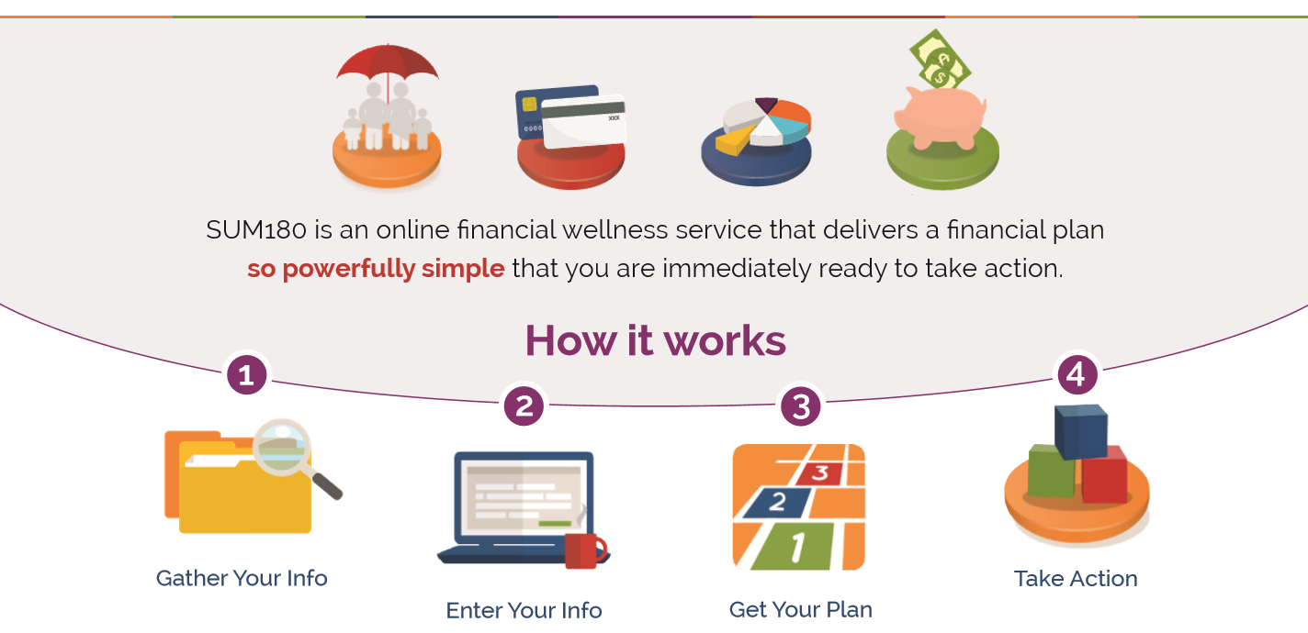
Now available through your HR department: SUM180, a financial wellness service that delivers a personalized plan for your money so powerfully simple that you are immediately ready to take action. SUM180 eliminates complicated jargon, so all you get is what you need right now: a clear picture of where you stand and three manageable next steps. Plus, you get access to financial advisers to provide coaching when you’re ready, and an online community for support and encouragement.
You may choose between a regular annual subscription ($129/year), a regular monthly subscription ($10.75/month) or a premium annual subscription ($199), which includes a 30-minute coaching session with a financial adviser.
A fitness program for your money
Start where you are, take a few next steps, track your progress, and celebrate the successes on your journey towards your goals. And, we know no one’s perfect – if you slip, just check back in when you’re ready. We’ll help you up and keep you moving forward!
